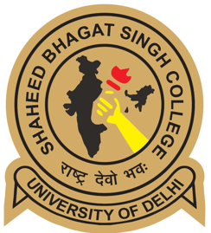
Faculty Details Proforma
Title | Ms. | First Name |  | Prerana | Last Name | Roy | Photograph
Designation |  | Asst. Professor |  |  |  |  | 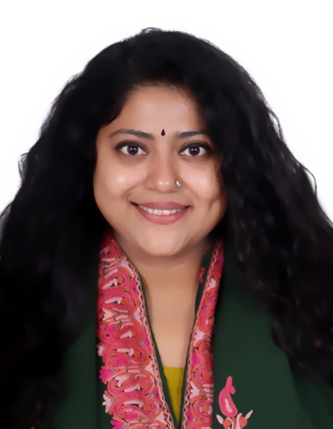
Address |  | Room 247, Godawari Hostel, new JNU Campus, New Delhi - 110067
Date of Birth |  | 06-11-1992
Phone No Office
Mobile |  | 9971464285
Email |  | prernapurnimaroy@gmail.com, prerana.roy@sbs.du.ac.in
Web-Page
Educational Qualifications
Degree |  |  | Institution |  |  |  | Year
PhD (Ancient Indian History) |  |  | Centre for Historical Studies, Jawaharlal Nehru University |  |  |  | 2023
MPhil (Ancient Indian History) |  |  | Centre for Historical Studies, Jawaharlal Nehru University |  |  |  | 2018
MA (Ancient Indian History) |  |  | Centre for Historical Studies, Jawaharlal Nehru University |  |  |  | 2016
BA |  |  | Dept. of History, Cotton College, Guwahati |  |  |  | 2014
Career Profile
- Asst. Professor, Department of History, Shaheed Bhagat Singh College, University of Delhi since 2.11.2023.
- Guest Lecturer, Department of History, College of Vocational Studies, University of Delhi from 9.2.2023-18.10.2023.
Areas of Interest / Specialization
History of Ancient and Early Medieval India - Social History, Gender History, History of Household and Kinship, History of Buddhism and Jainism
Papers Taught
- History of India- I (Core Course I, 1st Semester)
- History of India- II (Core Course III, 2nd Semester)
- History of India- V (Core Course V, 3rd Semester)
- Inequality and Difference (GE-VIII, 4th Semester)
- Understanding Indian Heritage (GE-IV, 2nd Semester)
- Museum and Museology (SEC, 2nd Semester)
- History of Modern China: c. 1840s-1950s (DSE IX, 5th Semester)
- Evolution of Tourism (DSC Minor 1.3, 1st Semester)
- Historical Tourism: Archaeology, Art and Architecture (SEC, 3rd semester)
Research Guidance
PhD scholars
Under Supervision | Submitted |  | Awarded
- | - |  | -
M.Phil Scholars
Under Supervision | Submitted |  | Awarded
- | - |  | -
M.A. Dissertations
Under Supervision |  | Awarded
- |  | -

Publications Profile
Books
Title |  | ISBN/Publisher/Link |  | Indexed Scopus, etc.  if any |  | Year
-
Research Publications
Article Name | Publication Type  (UGC Care/ Scopus/ Web of science etc) | Journal Name | ISSN No | Volume | Year | URL | DOI
Women and the Household in the Shadows of Marriage: The Ṛg Veda and Avestan Traditions | UGC Care listed | Proceedings of the Indian History Congress | 2249-1937 | 81 | 2023
Daughters, Brides and Wives: The Institution of Marriage in the Early Vedic Literature (c. 1000 BCE to 500 BCE) | UGC Care listed | Proceedings of the Indian History Congress | 2249-1937 | 79 | 2018 | https://rb.gy/yun97j | https://bit.ly/3E3GiNZ
The Gift of the Virgin: Kanyādāna in the Brahmanical Literature | UGC Care listed | Proceedings of the Indian History Congress | 2249-1937 | 78 | 2017 | https://rb.gy/9v25v3 | (htJ;ps://bit.ly/3WDTy3s)
Interpreting the Vivāha Saṃskāra in Ancient India from a Historiographical Perspective | UGC Care listed | Proceedings of the Indian History Congress | 2320-057X | 43 | 2018 | - | -
Publications other than journal articles
Title of Publication | Type of Publication | Publisher | Role in Publication | ISBN Number | Year | URL | Level
Art and History | Review/ Summary in the IIC Diary, (Vol.  XXXV, No. 1), p. 5. | India International Centre | Reviewer | 03769771  (ISSN no.) | Feb-Mar., 2021 | https://bit.ly/3WBSHju
Art for All | Review/ Summary in the IIC Diary, (Vol. XXXV, No. 4), p. 3. | India International Centre | Reviewer | 03769771  (ISSN no.) | Aug- Sept, 2021 | https://bit.ly/3zPwvst
Symbolic Associations | Review/ Summary in the IIC Diary, (Vol. XXXV, No. 6), p. 5. | India International Centre | Reviewer | 03769771  (ISSN no.) | Dec. 2021-Jan 2022 | https://bit.ly/3FNAbPa

Conference/ workshop Organized
Awards and Distinctions
• Won the Dr. Nasreen Ahmad Memorial Prize for the best paper on Gender History, titled ‘Women and the Household in the Shadows of Marriage: the Ṛg Veda and Avestan Traditions’, presented at the 81st Session of the Indian History Congress, (Madras Christian College, Chennai).
• Topped Gauhati University in the UG course for the subject History for the 2011-2014
batch.
• Qualified SLET (State Level Eligibility Test, North East region), 2017.
• Qualified NET (National Eligibility Test), 2018.
• Qualified for University Grants Commission's Post Graduate Merit Scholarship for
University Rank Holders at under Graduate Level i11Ap1il, 2014.
• Qualified for University Grants Commission's h1dira Gandhi Single Girl Scholarship in
Ap1il, 2014.
• Qualified for University Grants Commission's Swami Vivekananda Single Girl
Scholarship in Ap1il, 2017.
Association with Professional Bodies
- Associated with the office of the Secretary of the Indian History Congress, from 2018-2022.
- Intern Head, Lok Sabha Internship Programme, Parliament of India and the Lok Sabha
Secretariat under the Speakers Research Initiative (SRI) and the Bureau of Parliamentary
Studies (BPST) from 3rd July to 29th September, 2017.
- Worked with the Standing Committee for Coal and Steel, Questions Branch and the Ethics and Privileges Branch in a span of three months. Majorly contributed to the papers being tabled on to the Assembly sessions. Followed by two more months at the questions branch and the ethics and privileges unit within the Sansad Bhavan.
- Presented a paper on ‘A study of the Professional and Ethical Standards for Parliamentarians: Current trends in the Parliamentary protocols (With a special emphasis on the recent trends on the Disruptions in the House)’ at the end of the internship period.

Other Activities
• Research Assistant to Film Director Ridham Janve; April 2021 - January 2022 (10 months, Goa, India). Collated, analysed and provided historical insights, Sanskrit verses and other material for the film director Ridham Janve, from the early and post Vedic sources for a documentary on Aśvamedha, a later Ṛg Vedic horse sacrifice in the early Indian historical tradition.
• Research Assistant to historian, Prof. Rakesh Batabyal; August 2019 – November 2020 (1 year 4 months, New Delhi, India)
Worked as a researcher as well as on the editorial team under Westlai1d Books for the book 'The Modern School (1920-2020): A Century of Schooling in India'
• Research Assistant to historian, Prof. R. Mahalakshmi; April 2019-December 2019 (9 months), New Delhi, India
- Worked on the editorial team under Bloomsbury Publishing, India; for the book ‘Art and History: Texts, Contexts and Visual Representations in Ancient and Early Medieval India', edited by Prof. R. Mahalakshmi.

